Name : ………………………………………………………………..

Date Due : ………………………………………………………………..

 | Year 12 | 80% | A
 |  | 70% | B
 | AS Level Chemistry | 60% | C
 | 2008 - 2009 | 50% | D
 |  | 40% | E
 |  | Below | U
 | 1.4
 | Assessed Homework |  | %
 | Periodicity
 |  |  | 36
1. (a) (i) Complete the electronic configuration of aluminium.
1s2 ...............................................................................................................
(ii) State the block in the Periodic Table to which aluminium belongs.
........................................................................................................................
(2)
(b) Describe the bonding in metals.
.................................................................................................................................
.................................................................................................................................
.................................................................................................................................
(2)
(c) Explain why the melting point of magnesium is higher than that of sodium.
.................................................................................................................................
.................................................................................................................................
.................................................................................................................................
.................................................................................................................................
(3)
(d) Explain how metals conduct electricity.
.................................................................................................................................
.................................................................................................................................
.................................................................................................................................
(2)
(Total 9 marks)
2. The values of the first ionisation energies of neon, sodium and magnesium are 2080, 494 and 736 kJ mol–1, respectively.
(a) Explain the meaning of the term first ionisation of an atom.
.....................………………………………………………………………………….
.....................………………………………………………………………………….
.....................………………………………………………………………………….
(2)
(b) Write an equation to illustrate the process occurring when the second ionisation energy of magnesium is measured.
.....................………………………………………………………………………….
.....................…………………………………………………………………………. (2)

(c) Explain why the value of the first ionisation energy of magnesium is higher than that of sodium.
.....................………………………………………………………………………….
.....................………………………………………………………………………….
.....................………………………………………………………………………….
(2)

(d) Explain why the value of the first ionisation energy of neon is higher than that of sodium.
.....................………………………………………………………………………….
.....................………………………………………………………………………….
.....................………………………………………………………………………….
(2)
(Total 8 marks)

3. The diagram below shows the values of the first ionisation energies of some of the elements in Period 3.
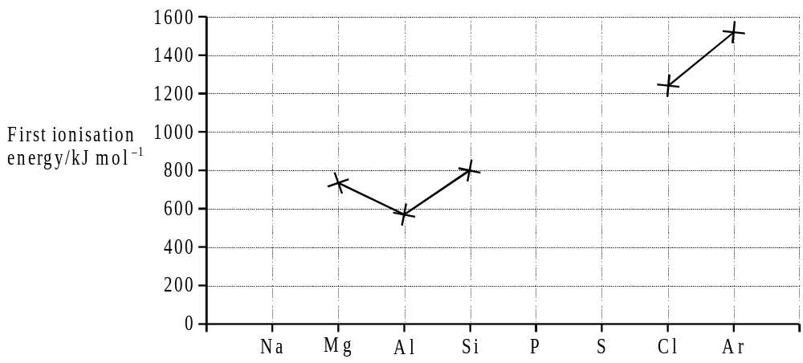

(a) On the above diagram, use crosses to mark the approximate positions of the values of the first ionisation energies for the elements Na, P and S. Complete the diagram by joining the crosses.
(3)
(b) Explain the general increase in the values of the first ionisation energies of the elements Na–Ar.
.................................................................................................................................
.................................................................................................................................
.................................................................................................................................
.................................................................................................................................
(3)
(c) In terms of the electron sub-levels involved, explain the position of aluminium and the position of sulphur in the diagram.
Explanation for aluminium .......................................................................................
.................................................................................................................................
.................................................................................................................................
Explanation for sulphur ...........................................................................................
.................................................................................................................................
.................................................................................................................................
(4)
(Total 10 marks)

4. The table below contains electronegativity values for the Period 3 elements, except chlorine.
Element | Na | Mg | Al | Si | P | S | Cl | Ar
Electronegativity | 0.9 | 1.2 | 1.5 | 1.8 | 2.1 | 2.5 |  | no value

(a) Define the term electronegativity
.................................................................................................................................
..............................................................................................................................................
(2)
(b) Explain why electronegativity increases across Period 3
…………………………………………………………………………………………………………………………………………………………………………………………………………………..
(2)

(c) Predict values for the electronegativities of chlorine and of lithium.
Electronegativity of chlorine ………………………………………………………………..
Electronegativity of lithium…………………………………………………………………..
(2)
(d) State and explain the trend in electronegativity down group II
Trend ………………………………………………………………………………………….
Explanation……………………………………………………………….....……….…………………………………………………………………………………………………………
(3)
(Total 9 marks )

